Your Mouth.
Your Health.
Your Life.

Everything you need to know about looking after your mouth - and why it matters far more than most people realise.

What's inside this guide:
• The basics - keeping your teeth and gums healthy for life
• When teeth don't align - and why it matters more than you think
• Aesthetics - your smile and your confidence
• Replacing missing teeth - why every tooth counts
• The oral microbiome - understanding your mouth's ecosystem
• The mouth-body connection - how your oral health affects your whole body

The Basics
Keeping your teeth and gums healthy for life
Your mouth is the gateway to your overall health. The fundamentals of good oral care are simple - but when they slip, the consequences compound quietly over time.
What good home care actually looks like
- Brush twice daily with a toothpaste recommended by your dentist - technique matters as much as frequency
- Floss or use interdental brushes once a day - plaque between teeth causes the majority of cavities
- Regular professional check-ups and cleans - even healthy mouths benefit from removal of tartar that brushing can't reach
- Reduce sugar frequency, not just quantity - every sugar exposure triggers an acid attack on your enamel
- Stay well hydrated - saliva is your mouth's natural defence system

Decay
How it happens - and how to stop it
Decay occurs when bacteria in your mouth feed on sugars and produce acid that slowly dissolves tooth enamel. Left untreated, it progresses through the tooth, causes pain and infection, and ultimately leads to tooth loss.
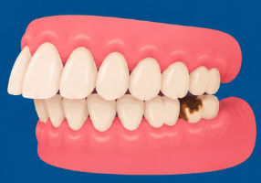
Decay is almost entirely preventable. The key is reducing how often your teeth are exposed to sugar - not just how much you consume - and brushing consistently to remove the bacterial plaque that drives the process.

Gum Disease
The silent destroyer of adult teeth
Gum disease is the leading cause of tooth loss in adults - and most people don't know they have it until it is well advanced. It begins as gingivitis (red, bleeding gums) and progresses silently, destroying the bone that holds your teeth in place.
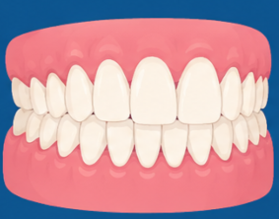
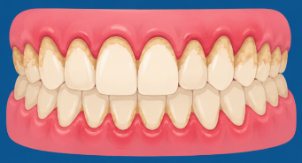
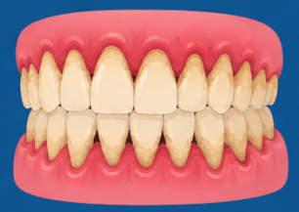

Early warning signs: bleeding when brushing, puffy or red gums, persistent bad breath, or gums that appear to be pulling back from your teeth.
Caught early, gum disease is very manageable. Left untreated, it leads to bone loss, loose teeth - and as you will read further in this guide, significant consequences for your whole body health.

When Teeth Don't Align
More than a cosmetic concern
Malaligned teeth are one of the most underappreciated sources of dental problems. They create conditions that even excellent brushing and flossing cannot fully address - and the damage builds quietly over years.
SMILE ZONE GUIDE
1 | Crowded or Overlapping Teeth  Difficult to clean effectively. Plaque collects between overlapping surfaces, driving higher decay and gum disease risk no matter how well you brush.

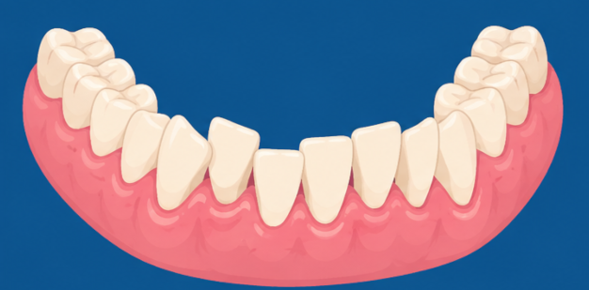
2 | Bite Misalignment  Uneven load distribution means some teeth absorb far more force than they were designed for - causing accelerated wear, cracking, and potential nerve damage over time.

3 | Overbite or Underbite  The jaw and teeth are not working as designed. Over time this causes uneven wear, jaw joint (TMJ) strain, and in some cases contributes to breathing difficulties.

4 | Gaps and Spacing  Spaced teeth generally self-clean well. However, gaps can indicate bone loss, previous tooth loss, or gum recession - all of which warrant a specialist review.

Orthodontic treatment is preventive healthcare - not a luxury. Addressing alignment issues protects your teeth from long-term damage that is both expensive and, in some cases, irreversible.
Your Smile and Your Confidence
Why aesthetics is not a luxury
There is often a reluctance to talk about wanting a nicer smile - as though it were somehow vain or superficial. But the evidence and the lived experience of patients tells a very different story.
"Your smile is one of the first things people notice about you. More importantly, it is something you notice about yourself - every time you look in the mirror, every time someone points a camera at you."

The real impact of smile confidence
- People who are unhappy with their smile often avoid photographs, cover their mouth when laughing, and hold back in social situations
- Smile confidence has a measurable effect on self-esteem, social engagement, and professional presence
- Patients who complete orthodontic treatment consistently report improvements in wellbeing that go far beyond their teeth
- This is not cosmetic - it is psychological, social, and genuinely health-related

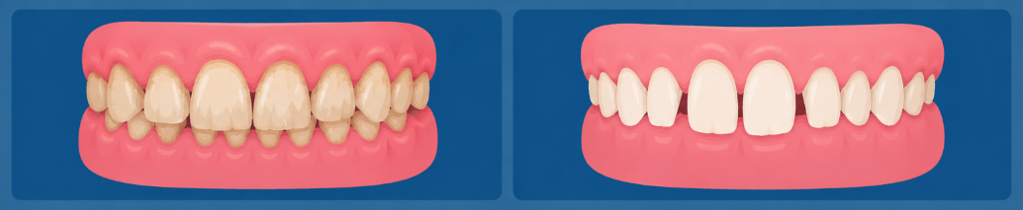

We encourage you to raise this with us. These are not frivolous requests - your confidence matters, and there are usually more options available than patients expect.

Replacing Missing Teeth
Why every tooth matters more than you think
It is easy to ignore a missing tooth - especially if it is at the back where no one can see it. But every tooth plays a role, and once it is gone, the consequences spread further and faster than most people expect.
What happens when a tooth is not replaced
→ | Neighbouring teeth begin to drift  Surrounding teeth tilt into the gap, shifting your bite and creating new alignment problems.

→ | Bone begins to resorb  The jawbone in the area shrinks because there is no longer a tooth root stimulating it. This begins within months of losing a tooth.

→ | The opposing tooth over-erupts  The tooth above or below the gap can grow too long, causing further bite problems and structural issues.

→ | Cleaning becomes harder throughout the mouth  Drifted and tilted teeth create new plaque traps, increasing decay and gum disease risk across multiple teeth.

→ | Chewing function is reduced  Missing teeth - particularly back teeth - compromise your ability to chew food effectively. Poor mastication means larger food particles enter the digestive system, placing extra strain on the stomach and gut, reducing nutrient absorption, and over time contributing to digestive discomfort, bloating, and gastrointestinal problems. Your digestion begins in your mouth.

The sooner a missing tooth is addressed, the simpler and more successful treatment tends to be. If you have a gap - even one you have had for years - please talk to us. It is rarely too late.

The Oral Microbiome
Understanding your mouth's ecosystem
Your mouth is home to over 700 species of bacteria - making it the second most diverse microbial environment in the human body after the gut. This ecosystem, known as the oral microbiome, plays a critical role in both your oral health and your general wellbeing.

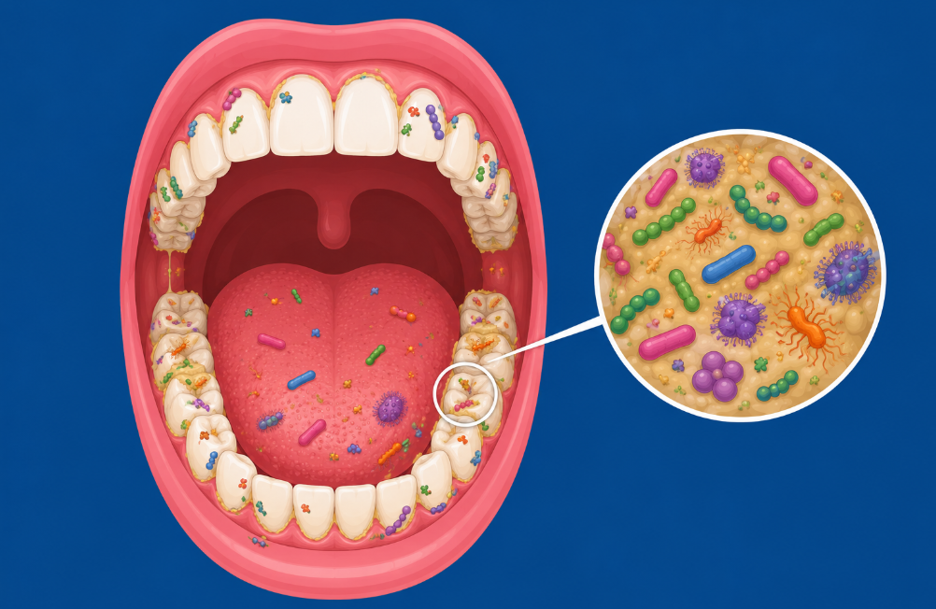
Not all oral bacteria are harmful. A healthy oral microbiome is a balanced one - where beneficial bacteria keep harmful species in check. The goal of good oral care is not to eliminate all bacteria, but to maintain that balance.

When the balance is disrupted
When harmful bacteria outcompete beneficial ones - through poor diet, inadequate hygiene, antibiotic use, or stress - a state called dysbiosis occurs. This is what drives decay, gum disease, and increasingly, systemic health consequences.
Factors that disrupt the oral microbiome
- High sugar diets - feed harmful acid-producing bacteria like Streptococcus mutans
- Mouth breathing - dries out saliva, which is a critical microbiome regulator
- Antibiotic use - can wipe out beneficial bacteria alongside harmful ones
- Stress - raises cortisol, which suppresses the immune response in the mouth
- Smoking and alcohol - strongly associated with harmful shifts in microbial populations

What a healthy oral microbiome looks like
- Saliva flows freely and consistently - rinsing, buffering acid, and delivering beneficial compounds
- Beneficial bacteria produce nitric oxide precursors that support cardiovascular health
- Healthy gum tissue acts as a barrier, keeping oral bacteria from entering the bloodstream
- Regular professional cleaning removes biofilm (plaque) that home care cannot reach

Emerging research links the oral microbiome to conditions including Alzheimer's disease, colorectal cancer, rheumatoid arthritis, and more. Looking after your mouth is, quite literally, looking after your brain and body.

The Mouth-Body Connection
How your oral health affects your whole body
For many years, dentistry was treated as entirely separate from the rest of medicine. We now know this is simply not true. The health of your mouth has a direct, documented, and increasingly well-understood impact on your general health.
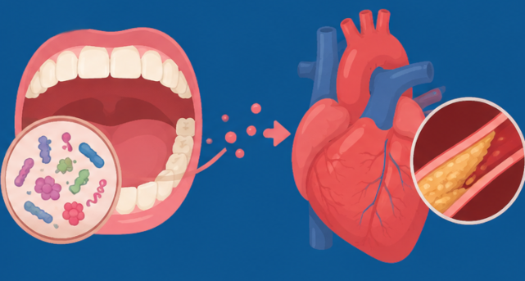
Bacteria and inflammatory markers from your mouth can enter your bloodstream and affect organs and systems far removed from your teeth and gums. The pathway runs in both directions - poor general health also worsens oral health.

What the evidence shows
Heart Disease and Stroke
✓ Gum disease is strongly and independently associated with increased cardiovascular risk
✓ Oral bacteria have been identified in arterial plaque and heart valve tissue
✓ People with severe periodontitis have a significantly higher rate of heart attack and stroke

Diabetes
✓ The relationship works both ways - diabetes worsens gum disease, AND gum disease makes blood sugar harder to control
✓ Treating gum disease has been shown to measurably improve HbA1c levels in diabetic patients
✓ People with diabetes should discuss more frequent dental monitoring with their dentist

Pregnancy
✓ Pregnancy gingivitis is very common due to hormonal changes and requires proactive care
✓ Severe gum disease during pregnancy is associated with premature birth and low birth weight
✓ Dental care is safe and important throughout pregnancy - please do not delay it

Brain Health and Dementia
✓ The bacterium Porphyromonas gingivalis - a key driver of gum disease - has been found in the brains of Alzheimer's patients
✓ Chronic oral inflammation may contribute to neuroinflammatory pathways
✓ Tooth loss itself is associated with increased cognitive decline risk in longitudinal studies

Respiratory Health
✓ Oral bacteria can be aspirated into the lungs, worsening respiratory infections and conditions
✓ Poor oral health is associated with pneumonia, particularly in older and hospitalised patients
✓ Patients with COPD or asthma benefit particularly from excellent oral hygiene

The single most powerful thing you can do for your long-term health is to take your oral health seriously. It is not just about your teeth - it is about your heart, your brain, your lungs, and your quality of life.

Patient Assessment Record
To be completed by the dental team during or after the consultation.
Area Discussed | Assessed - No Concerns | Treatment / Review Advised | Not Yet Assessed
Home care routine - brushing and interdental cleaning | ☐ | ☐ | ☐
Decay risk assessment | ☐ | ☐ | ☐
Gum health - gingivitis or periodontal disease | ☐ | ☐ | ☐
Tooth alignment and bite | ☐ | ☐ | ☐
Aesthetics - smile confidence discussed | ☐ | ☐ | ☐
Missing teeth - replacement options discussed | ☐ | ☐ | ☐
Chewing function and dietary impact | ☐ | ☐ | ☐
Oral microbiome - diet and lifestyle factors | ☐ | ☐ | ☐
Oral-systemic health link - relevant conditions | ☐ | ☐ | ☐
Referral recommended (orthodontic / specialist) | ☐ | ☐ | ☐

Patient name:  ___________________________________  Date:  ___________________________________ | Treating clinician:  ___________________________________  Next review:  ___________________________________
Notes / follow-up items:

The most important appointment
you can make this year
You have just read about how your mouth connects to your heart, your brain, your gut, your lungs, and your confidence. That connection works in both directions - and it starts with a single conversation with your dental team.

Three things to remember
Prevention is always  simpler and less costly than treatment. Regular check-ups catch problems early - before they become complex. | Your mouth reflects  your whole body's health - and affects it. Oral health is not separate from general health. It is part of it. | It is never too late  to start. Whatever the current state of your mouth, there is always something that can be improved, protected, or preserved.

